**Попарное тестирование**

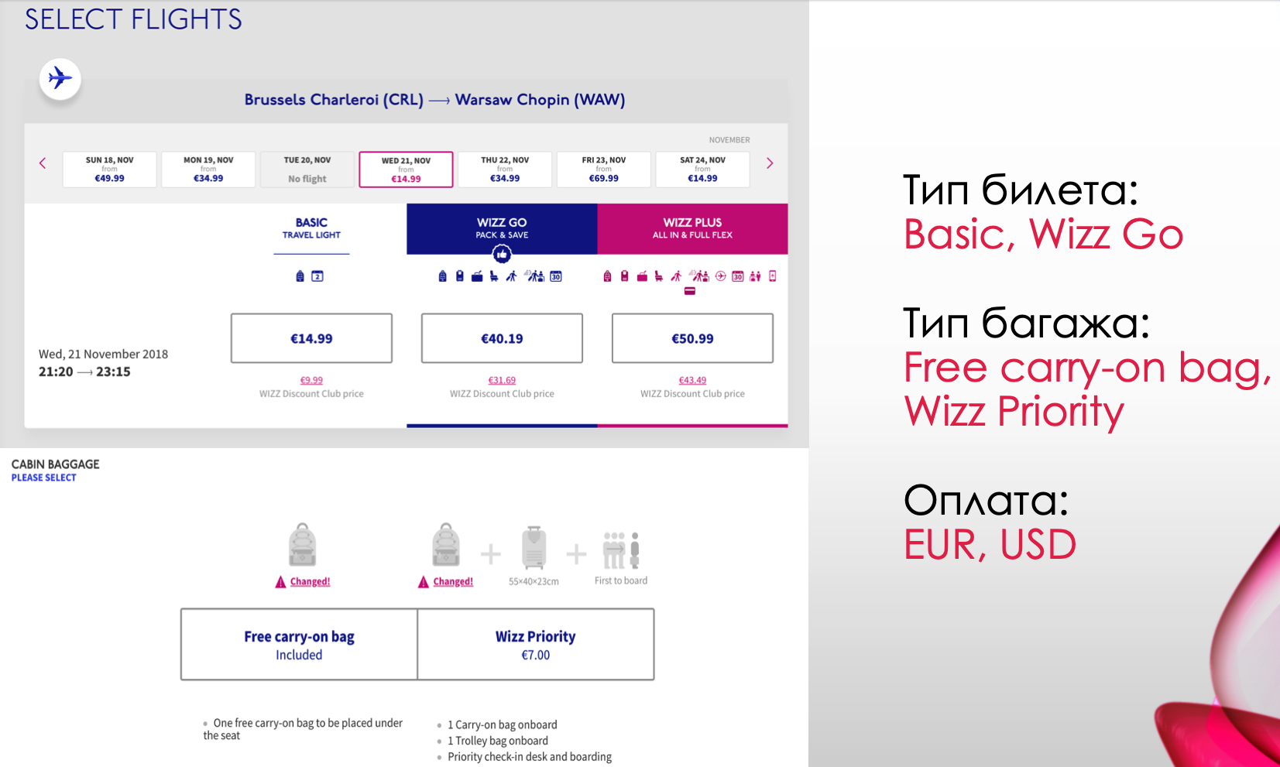

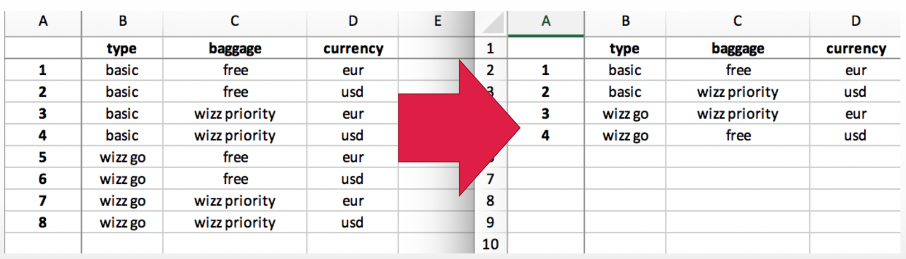[**https://pairwise.teremokgames.com/**](https://pairwise.teremokgames.com/)